# Simple Coding Puzzles

## 1: Morse Code

The users enters ONE character, you display the morse code for that character

## 2: Cypher

The user enters ONE character, you display the encrypted letter. Use a rotational / Caesar cypher, e.g. a is changed to a m, b is changed to an n

## 3: Very Odd!

Allow the user to enter a number. Display if it is odd or even. (Hint: investigate the MOD operator – the percentage % …. 10 % 4 is 2)

## 4: Calculator

Allow the user to enter two numbers and an operator. Perform the calculation. Operators allowed +, -, *, /

e.g. My inputs are:

* 10
* 2
* *

You output “20”

## 5: You’ve been framed!

Allow the user to enter 4 words. Display the 4 words with a frame around them:

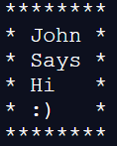

Hint: you will need to investigate the len() function. https://www.geeksforgeeks.org/python-string-length-len/

## 6: 5 but right aligned

Take a copy of solution 5, change the code so the words are right aligned:

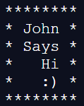

## 7: Stock Codes

You have been approached by Sanjiv, he is expanding his book shop and has employed a number of new staff. The staff are having problems remembering Sanjiv’s strange stock codes and what they mean. Write a small program that helps new staff members understand his codes:

* **BK1F12O**
* **GM2G09I**
* **BG2B01I**

The codes are broken down as:

* First two characters are the “thing”, e.g. BK is a book, GM is a computer game, BG is a board game.
* Character 3 is a digit – the floor number. Sanjiv’s shop has 3 floors, 1, 2 and 3.
* Fourth character is section, F is fiction, G is games, B is board games.
* Fifth and sixth are digits, this is the shelf code.
* Last character is O – out of stock, I in stock.

Write a program that allows a code to be entered and a description of the item output.

## 8: Advanced

Investigate **for loops**, and how to correctly indent your code. Then investigate the following code:

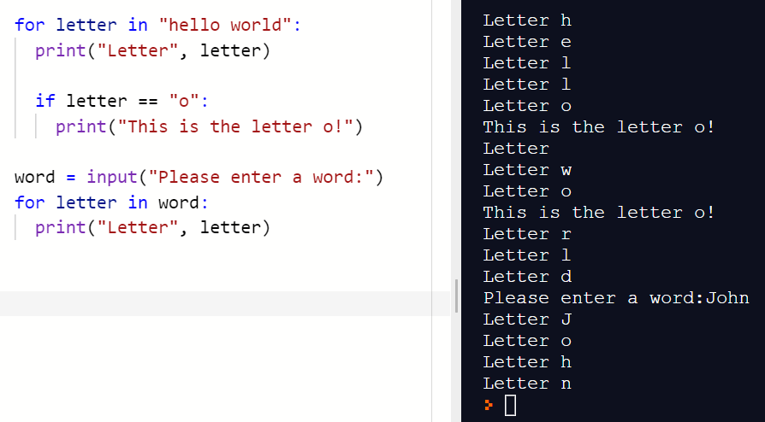

Using the results of your investigation, “fork” (take a copy of) your code for problem 1 and allow the user to enter a string of characters. Display the morse code for this string.

## 9: Weird, hard, interesting

Investigate:

* Radius of the planet earth
* The depth of the atmosphere in which humans can comfortably live (e.g. top of Everest is too high, too cold, not enough air)

Can you display this information graphically?